Standard Operating Procedure

**Hybrid Scenario Manager Quotes**

Audience: Sales Rep, Order Entry, LATAM Order Manager

Version [1.0]

Table of Contents

1. Scope 2

2. Roles Impacted and Main Activities 2

3. Applications Involved 2

4. Hybrid Scenario Manager Quotes 3

4.1 High Level Flowchart 3

4.2 Detailed Steps 5

4.2.1 Centralized Billing in NA/EMEA/APAC 5

4.2.1.1 Quoting - BANs creation – Order submission 5

4.2.1.2 Ordering 6

4.2.2 Centralized Billing in LATAM 6

4.2.2.1 Quoting - BANs creation – Order submission 6

4.2.2.2 Ordering 7

5. Reference Material 8

5.1 Related Links 8

5.2 Version History 8

# Scope

The purpose of this document is to explain two different flowcharts:

* Quoting, BAN creation, and Order processing when there is a hybrid Scenario Manager quote sold in NA/EMEA/APAC with termination in LATAM, with **centralized billing in NA/EMEA/APAC.**
* Quoting, BAN creation, and Order processing when there is a hybrid Scenario Manager quote sold in NA/EMEA/APAC with termination in LATAM, with **centralized billing in LATAM.**

# Roles Impacted and Main Activities

|  |  |
| --- | --- |
| **Role** | **Main Activities** |
| Imagen1.png  Sold Region Sales Rep | * Create Salesforce Account * Submit AM or LEXM BAN request * Assign LEXM shell BAN to existing Kenan BAN * Assign BANs to products |
| Imagen1.png  Sold Region Order Entry | * Create EON order * Assign BAN to order |
| Imagen1.png  Latam Order Manager | * Review and approve Latam BAN requests * Assign Siebel 8 order to customer account and BAN * Create new Latam BAN |

# Applications Involved

The table below presents end- user applications related to these processes

| **Application** | **Production Link** |
| --- | --- |
| Salesforce | <https://ctl.my.salesforce.com/> |
| Account Management | <http://am/AMWeb/> |
| BAN Sharepoint | https://applications.level3.com/sites/FI_Dashboards/CH/SitePages/Home_New.aspx |
| EON | http://eon-prod.level3.com/eon/base/login.jsp |
| Siebel 8 | <http://siebellat.corp.global.level3.com/ecommunications_esn/start.swe> |

# Hybrid Scenario Manager Quotes

## High Level Flowchart

Global Product + Legacy Product SM Quote – Centralized billing in **NA/EMEA/APAC**

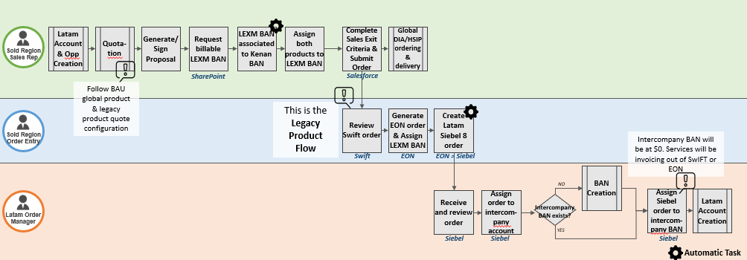 **Option A**

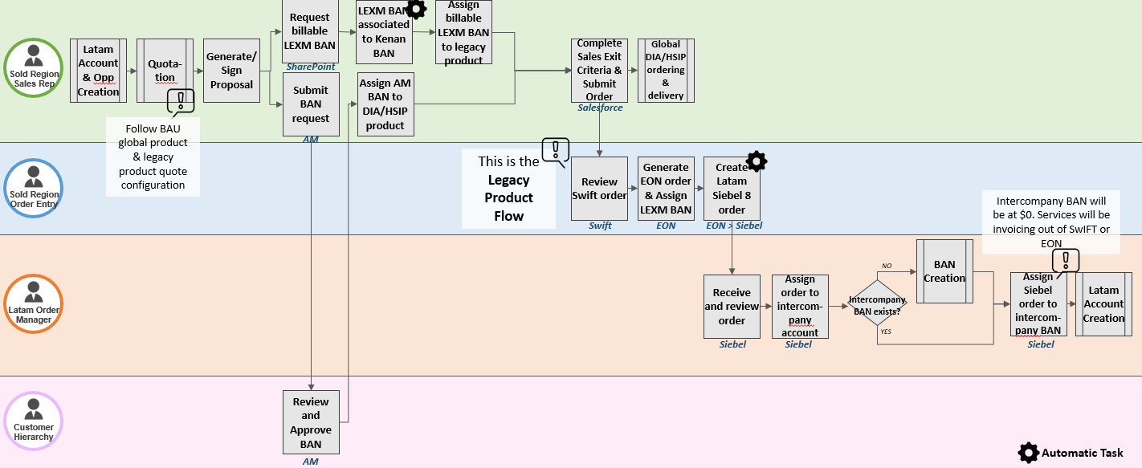**Option B**

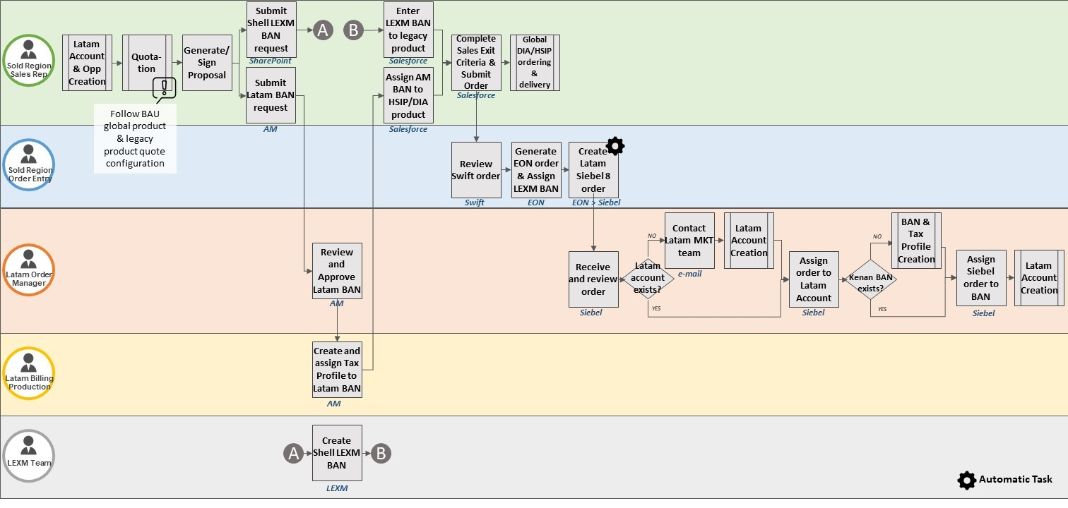Global Product + Legacy Product SM Quote – Centralized billing in **LATAM**

## Detailed Steps

### Centralized Billing in NA/EMEA/APAC

#### Quoting - BANs creation – Order submission

**Role: Sold region Sales Rep**

Follow the next steps in the following scenario: A Scenario Manager quote that contains a global product (DIA/HSIP) and a legacy product (Wave, EPL, PL Hub only), that is a NA/EMEA/APAC sold with termination in LATAM and centralized billing in sold region.

1. If it is a new customer, create a new customer account in Salesforce. If it is an existing customer, create a new opportunity.
2. Create a new quote and complete the product quote configuration for each product as usual.
3. Generate and get the proposal signed by the customer.
4. There are two possible options regarding the BAN creation and assignment:

* Option A:

1. Request a billable LEXM BAN through the Sharepoint. That BAN is automatically associated to the Kenan BAN. This provides us with a LEXM ‘02’ BAN that EON requires. Kenan BANs cannot be used in EON.
2. In Salesforce, assign both global and legacy product to the LEXM BAN. Both products will invoice through the same BAN.

* Option B:

1. Go to the Account Management application and submit a new BAN request to Customer Hierarchy. This Kenan BAN will be a billable BAN.

Customer Hierarchy will review and approve the requested BAN.

1. Request a billable LEXM BAN through the Sharepoint. That BAN is automatically associated to the Kenan BAN. This provides us with a LEXM ‘02’ BAN that EON requires. Kenan BANs cannot be used in EON.
2. In Salesforce, assign the global product to the Kenan BAN and the legacy product to the LEXM BAN, before submitting the quote to order. Each product will invoice on two different BANs.
3. Complete all the sales exit criteria as usual.
4. Submit the order.
5. The global product (DIA/HSIP) order will route to SwIFT **without** a task to generate an EON order. This will follow the global path.
6. The legacy product (Wave, EPL, PL Hub only) order will route to SwIFT **with** a task to generate an EON order. This flow will be explained below.

#### Ordering

This is the step by step of the legacy product ordering flow:

**Role: Sold region Order Entry**

1. Generate a new EON Order.
2. Assign the LEXM BAN to the EON order.

The EON services will invoice to the customer through the LEXM BAN. This LEXM BAN is associated to the billable Kenan BAN that the global product (DIA/HSIP) are assigned to. This means that the global and legacy products will invoice on the same BAN.

1. The EON order will automatically generate a Siebel 8 shell order for LATAM Order Manager.

**Role: Latam Order Manager**

1. Assign the Siebel 8 shell order to an intercompany account and BAN.  The BAN will be $0 because services are invoicing through EON.
2. LATAM Service Delivery activates Siebel services and LATAM CCM completes order.

### Centralized Billing in LATAM

#### Quoting - BANs creation – Order submission

**Role: Sold region Sales Rep**

Follow the next steps in the following scenario: a Scenario Manager quote that contains a global product (DIA/HSIP) and a legacy product (Wave, EPL, PL Hub only), that is a NA/EMEA/APAC sold with termination in LATAM and centralized billing in LATAM.

1. If it is a new customer, create a new Latam customer account in Salesforce. If it is an existing customer with a Latam account created, create a new opportunity.
2. Create a new quote and complete the product quote configuration for each product as usual.

Sales must confirm that the quote has been generated against a LATAM customer account. This is important because LATAM BANs must be assigned to LATAM customer accounts.

1. Generate and get the proposal signed by the customer.
2. Go to the Account Management application and submit a new BAN request to LATAM Order Manager. This Kenan BAN will be a billable BAN.

LATAM Order Manager will review and approve the requested BAN.

LATAM Billing Production will create and assign a Tax Profile to the BAN.

1. Go to the BAN request SharePoint and request a stand-alone LEXM shell BAN.

The team that creates the LEXM BANs in LEXM will receive the request and create the LEXM ‘02’ BAN. They are created as a shell/non-billable BAN and are not sent to Kenan. This is because the services will be assigned to Kenan billable BAN on the Siebel 8 order.

1. In Salesforce, select the Kenan BAN to assign to the global product (DIA/HSIP).
2. Select the legacy product and then manually enter the LEXM ‘02’ BAN in the “LEXM BAN field” in Salesforce. Then click on the “Update Selected” button.

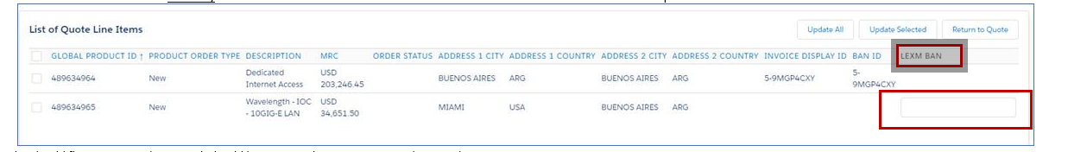

1. Complete all the sales exit criteria as usual.
2. Submit the order.
3. The global product (DIA/HSIP) order will route to SwIFT **without** a task to generate an EON order. This will follow the global usual path.
4. The legacy product (Wave, EPL, PL Hub only) order will route to SwIFT **with** a task to generate an EON order. This flow will be explained below.

#### Ordering

This is the step by step of the legacy product ordering flow:

**Role: Sold region Order Entry**

1. Generate a new EON Order.
2. Assign the LEXM BAN to the EON order.

The EON services will not invoice to the customer because the LEXM BAN is a non-billable BAN and is not associated to any other Kenan BAN in this case. This is because the legacy products services will be invoiced through the Kenan BAN on the Siebel 8 order.

1. The EON order will automatically generate a Siebel 8 shell order for LATAM Order Manager.

**Role: Latam Order Manager**

1. Assign the Siebel 8 order to the existing LATAM customer account from step 1.

If the account where the quote was generated, had been a non-LATAM customer account, then LATAM Order Manager would contact LATAM Marketing to create a duplicate customer account for the LATAM legal entity and the Siebel 8 order and billable BAN would be assigned to this account. This means that there would be two separate customer accounts and BANs.

1. Assign the Siebel 8 order to the Kenan BAN that was used for the global product (DIA/HSIP). This means that the global and legacy products will invoice on the same BAN.

**Important:** Verify if there is an existing Kenan BAN to assign to the order. If not, then create a new one.

1. LATAM Delivery activates Siebel services and LATAM CCM completes order

# Reference Material

## Related Links

## Version History

Electronic copies in any location other than the GSL, plus all printed copies, are uncontrolled.

| **Version** | **Date Published** | **Business Process Owner (Region)** | **Document Writer** | **Summary of Changes** |
| --- | --- | --- | --- | --- |
| 1.0 | 00/00/14 | PO Name (region) | Writer Name | First publication to GSL. |
|  |  |  |  |  |

©CenturyLink Communications, LLC., 2020 - This document may not be transmitted, reproduced, stored and/or retrieved from any type of electronic system for the purposes of reproduction without the express written consent of CenturyLink Communications, LLC. No warranty, expressed or implied, shall be provided or construed through use of the information contained in this document or the services, work, or deliverables provided based upon the contents of this document.